QUEUE AND SERVICE FLOW MANAGEMENT SYSTEM FOR GOVERNMENT OFFICES IN NEPAL

BY
SIDDHARTHA SHAKYA
T.U. REGISTRATION NO. 7-2-551-88-2023
SYMBOL NO. 16055/23
NATIONAL COLLEGE OF COMPUTER STUDIES

A Project Report Submitted To
FACULTY OF MANAGEMENT, TRIBHUVAN UNIVERSITY
in partial fulfillment of the requirements for the degree of
BACHELOR OF INFORMATION MANAGEMENT (BIM)

Paknajol, Kathmandu
September, 2026

STUDENT DECLARATION
This is to certify that I have completed the Project entitled “Queue and Service Flow Management System for Government Offices in Nepal” under the guidance of “Teksan Gharti Magar” in partial fulfillment of the requirements for the degree of Bachelor of Information Management at Faculty of Management, Tribhuvan University. This is my original work, and I have not submitted it earlier elsewhere.

Date: 2026/09/13 Signature:
Name: Siddhartha Shakya

CERTIFICATE FROM THE SUPERVISOR
This is to certify that the project entitled “Queue and Service Flow Management System for Government Offices in Nepal” is an academic work done by “Siddhartha Shakya” submitted in the partial fulfillment of the requirements for the degree of Bachelor of Information Management at Faculty of Management, Tribhuvan University under my guidance and supervision. To the best of my knowledge, the information presented by him in the project report has not submitted earlier.
______________________________
Signature of the Supervisor
Name: Teksan Gharti Magar
Designation:
Date:

APPROVAL SHEET
This is to certify that the project titled Queue and Service Flow Management for Government Offices in Nepal submitted by Siddhartha Shakya has been examined and approved. In our opinion, it meets the required scope and quality standards for a project submitted in partial fulfillment of the requirements for the degree of Bachelor of Information Management (BIM).
Approval Panel:
S.No. | Name | Designation | Signature
1 | Teksan Gharti Magar | Project Supervisor
2 | Rajan Poudel | Program Coordinator
3
4

Date of Defense: 2026/09/13
Department: Faculty of Management
Faculty: Bachelors in Information Management (BIM)

ACKNOWLEDGEMENTS
I would like to express my sincere gratitude to my project supervisor, Mr.Teksan Gharti Magar, for providing guidance and supervision throughout the development of this project. His guidance has been valuable in shaping the project requirements, technical direction, and report preparation.
I am also grateful to the Faculty of Management, Tribhuvan University, and National College of Computer Studies for providing the academic environment and resources required to undertake this project. I would like to acknowledge the Department of IT and those who contributed feedback and support during the development of the system.
Finally, I would like to thank everyone who provided encouragement and assistance during the preparation and completion of this project.
………………………
Siddhartha Shakya
Symbol No: 16055/23
T.U. Registration No: 7-2-551-88-2023
September, 2026

ABSTRACT
Government services may involve several physical stages even when part of the application process is digital. Citizens can still face uncertainty about service procedures, required documents, office locations, queue position, and the next stage of a service journey. This project presents a Service Flow Management System for Government Offices in Nepal as a Progressive Web App for registered citizens, staff, and administrators. At the current mid-defense stage, the system provides user account management, government-office and service information, service stages and required-document guidance, digital token generation, queue-position reservation, counter processing, and citizen notifications. The design treats government service as a multi-stage flow rather than only a single queue. Later increments are planned for more advanced queue estimation, real-time communication, analytics, and AI-based service-duration prediction. The project is developed as an academic prototype and does not claim production integration with real government databases.
Keywords: service flow management, queue management, digital tokens, service stages, waiting-time information, Progressive Web App, government service, Nepal

TABLE OF CONTENTS
STUDENT DECLARATION ii
CERTIFICATE FROM THE SUPERVISOR iii
APPROVAL SHEET iv
ACKNOWLEDGEMENTS v
ABSTRACT vi
LIST OF FIGURES ix
LIST OF TABLES x
LIST OF ABBREVIATIONS xi
CHAPTER I: INTRODUCTION 12
1.1 Background of the Project 12
1.2 Problem Statement 12
1.3 Objectives 13
1.4 Review of Related Work and Literature 13
1.5 Development Methodology 14
1.6 Scope and Limitations 15
1.6.1 Scope 15
1.6.2 Limitation 15
1.7 Report Organization 15
CHAPTER II: SYSTEM DEVELOPMENT PROCESS 16
2.1 Analysis 16
2.1.1 Requirement Analysis 16
2.1.2 Feasibility Study 18
2.1.3 System Modelling 19
2.2 Design 21
2.2.1 Interface and Dialogue Design 21
2.2.2 Database Design 22
2.3 Implementation 23
2.3.1 Tools and Technologies Used 23
2.3.2 Implementation Details of Modules 23
2.3.3 Testing 23
CHAPTER III: CONCLUSION AND RECOMMENDATION 25
3.1 Summary 25
3.2 Conclusion 25
3.3 Recommendation 25
REFERENCES 26
APPENDIX a

LIST OF FIGURES
Figure 2.1: Use Case Diagram 17
Figure 2.2: Gantt Chart 19
Figure 2.3: Conceptual ER Diagram 20
Figure 2.4: Context Diagram 20
Figure 2.5: Level 1 DFD 21
Figure 2.6: High fidelity design of the system 21

LIST OF TABLES
Table 2.1: Functional Requirements 16
Table 2.2: Non-Functional Requirements 17
Table 2.4: Technology Stack 23
Table 2.5: Sample Unit Test Cases 24

LIST OF ABBREVIATIONS
Abbreviation | Meaning
AI | Artificial Intelligence
API | Application Programming Interface
DFD | Data Flow Diagram
ERD | Entity Relationship Diagram
JWT | JSON Web Token
ML | Machine Learning
OTP | One-Time Password
PWA | Progressive Web App
QR | Quick Response
RBAC | Role-Based Access Control
REST | Representational State Transfer
UI | User Interface
UX | User Experience

CHAPTER I:
INTRODUCTION

1.1 Background of the Project
Government service delivery is increasingly supported by digital systems, but digitization does not necessarily eliminate all physical stages of service. In many service journeys, citizens may still need to visit an office, move between rooms or counters, submit documents, complete service stages, and wait for staff attention. A citizen may therefore face uncertainty not only about whether a service is available online, but also about what must happen after reaching the physical office.
The proposed Queue and Service Flow Management System addresses this gap by treating government service delivery as a multi-stage flow rather than only as a queue. The system is intended to help citizens understand a service before visiting, follow a roadmap of stages, identify the documents required at each stage, understand where to proceed, generate a same-day digital token, monitor the queue, and receive notifications as their turn approaches. The application is designed as a Progressive Web App so that citizens can access it through a browser and install it when supported without requiring a separate native mobile application.
The queue component is designed around a defined fairness policy. Creating a token reserves the citizen’s queue position, while physical arrival at the actual service counter confirms presence without changing the original queue position. There is no separate check-in counter or kiosk. When a token is called, the citizen proceeds to the assigned counter, where staff verifies the QR code or token manually and then begins service. A configurable grace period, skipping, controlled recall, and deferred-service mechanisms address common operational cases such as absence and office closure.
Waiting-time information is designed to be dynamic. Instead of relying only on the number of people ahead multiplied by a single average duration, the system considers current queue progress, recent service durations, active counters, counter availability, priority handling, skips, recalls, and other live queue events. The AI component supports this process by predicting expected service duration from service and operational context. The prediction is advisory input to the deterministic queue engine; it does not decide queue order, priority, skipping, recall, completion, or stage transition.
The present project is an academic prototype. The project context identifies transportation-office-style multi-stage services as a practical reference domain, but current official government procedures and operational statistics are not stated as verified facts in this draft. Such claims should be supported by current authoritative sources before the final report is submitted.

1.2 Problem Statement
Although government services are increasingly digitized, citizens may still experience confusion and inefficiencies during physical stages of service delivery. They may not know the sequence of procedures, where to go next, what documents are required at each stage, or how long they may need to wait. This can lead to repeated inquiries, crowding around counters or display boards, uncertainty about service progress, and inefficient service-flow management for staff.
A physical queue management solution alone does not fully address the problem when a service consists of several stages, because citizens need guidance about what happens before and after a queue interaction. In addition, remote token generation creates a fairness concern when physical arrival time is allowed to override the reserved queue position. Variable service durations also make static waiting-time calculations unreliable. Citizens who miss a call near the end of office hours may repeatedly experience disadvantages if there is no controlled mechanism for recall or carry-over.
Therefore, the project focuses on a service-flow platform that combines citizen guidance, stage-aware queue management, counter-level verification, dynamic waiting-time estimation, notifications, and operational controls in a single system.

1.3 Objectives
- To design and develop a Service Flow Management System that provides citizens with step-by-step guidance, service-stage information, real-time service status, and dynamic waiting-time information throughout the physical stages of government service delivery.
- To improve the efficiency and transparency of service operations by enabling queue management, service-flow monitoring, stage transitions, and data-driven decision support for staff and administrators.

1.4 Review of Related Work and Literature
Queue management is both an operational problem and a human-experience problem. Larson (1987) explains that people do not judge a queue only by elapsed time; perceptions of fairness and adherence to service order can strongly influence attitudes toward waiting. This is relevant to the project because token generation is intended to reserve queue position, while arrival at the service counter confirms presence without automatically changing the reserved position. Literature therefore supports treating fairness and transparency as explicit queue-design concerns.
Waiting for information is another important service-design factor. Hui and Tse (1996) found that information about waiting duration and queue conditions can affect service evaluations, while Taylor (1994) showed that delays and uncertainty can reduce evaluations of service. Pruyn and Smidts (1998) further showed that objective waiting time affects satisfaction partly through perceived waiting time and the way customers evaluate the waiting experience. More recent evidence from virtual queues also shows that the magnitude and update frequency of waiting-time information can influence customer abandonment behavior (Yu et al., 2022). These findings support providing citizens with understandable queue status and waiting information rather than leaving them without feedback.
Queue management systems have also been studied in practical service environments. Bidari et al. (2021) evaluated a queue management system in an emergency department and reported lower actual and perceived waiting times together with higher patient satisfaction in the intervention group. This demonstrates that effective queue management can improve not only operational efficiency but also the user's experience of the service.
The reviewed studies, however, generally focus on waiting-line management, customer perceptions, or specific service environments such as healthcare and virtual queues. They do not directly combine the complete physical journey of a government service with stage-by-stage guidance, stage-specific document requirements, reserved queue position, counter-level verification, and service-flow transitions. The proposed project addresses this gap by treating government service delivery as a multi-stage service-flow problem rather than only as a waiting-line problem. At the current mid-defense stage, the implemented scope covers the foundational account, service, stage, document, token, counter, and notification modules; broader dynamic waiting-time estimation and AI-based service-duration prediction remain planned extensions.

1.5 Development Methodology
The project follows the Incremental Waterfall Model. The approach was selected because it provides a structured sequence of requirements analysis, design, implementation, and testing while allowing the system to be developed and documented in manageable increments. This approach is suitable for an individual academic project with a defined scope and milestone-based supervision.
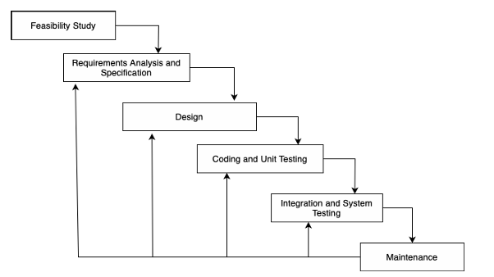
Figure 1.1: Incremental Waterfall Model

1.6 Scope and Limitations

1.6.1 Scope
At the current mid-defense stage, the implemented system covers registered-user account access, English/Nepali language preference, government-office and service information, service stages, stage-specific required documents, digital token generation, queue-position reservation, current-stage tracking, counter information, token processing, and citizen notifications. The current conceptual database contains Government Office, User, Service, Service Stage, Required Document, Token, Counter, and Notification entities.
The current staff scope centers on token and counter processing supported by the implemented build, while the Administrator role provides the role-based access required by the current foundation. More advanced priority, recall, deferred-service, analytics, audit, and policy-management functions remain planned for later increments.
The citizen application is implemented as a Progressive Web App, with Node.js/Express and PostgreSQL with Prisma supporting the current web application. Real-time communication and AI-based service duration predictions are planned later increments rather than completed mid-defense functionality.

1.6.2 Limitation
- The current project is an academic prototype and is not intended for national-scale deployment.
- Right now, OTP is sent to backend console, and there is no SMS gateway integration.
- The current implementation is not integrated with live government databases or existing government portals.
- Real operational queue and service-duration data are not yet available for production-level evaluation.
- Payment processing, National ID integration, biometric authentication, appointment scheduling, mandatory production SMS integration, and a separate check-in kiosk are outside the current scope.

1.7 Report Organization
Chapter I, Introduction, presents the background, problem statement, objectives, review of related work and literature, development methodology, scope and limitations, and organization of the report. Chapter II, System Development Process, presents analysis, requirements, feasibility, system modelling, interface and database design, implementation technologies, important system modules, and testing. Chapter III, Conclusion and Recommendation, summarizes the work, states the conclusion based on the achieved system, and presents recommendations for future development. The report ends with references and appendices.

CHAPTER II:
SYSTEM DEVELOPMENT PROCESS

2.1 Analysis

2.1.1 Requirement Analysis
Requirement analysis identifies the functional and non-functional behavior needed by the proposed service-flow platform. The system has three primary actor groups: Citizen, Staff, and Administrator. The requirements below are derived from the finalized project scope and are intended to guide the subsequent design and implementation.
i. Functional Requirements
Table 2.1: Functional Requirements
ID | Requirement | Description
FR1 | User registration and login | The system shall allow users to register and authenticate to the system.
FR2 | Language preference | The system shall support English and Nepali as citizen-facing language options.
FR3 | Service information | The system shall allow citizens to browse government office and service information.
FR4 | Service stages and documents | The system shall display service stages and stage-specific required documents.
FR5 | Token generation | The system shall generate a digital token and reserve the citizen's queue position according to the implemented policy.
FR6 | Counter and token processing | The system shall support token processing at the service counter and maintain current-stage and status information.
FR7 | Notifications | The system shall provide notifications for supported service and token events.
FR8 | Role-based access | The system shall provide role-appropriate access for citizens, staff, and administrators.
The functional requirements can be represented using a Use Case Diagram showing the interactions of Citizen, Staff, and Administrator with the implemented system.
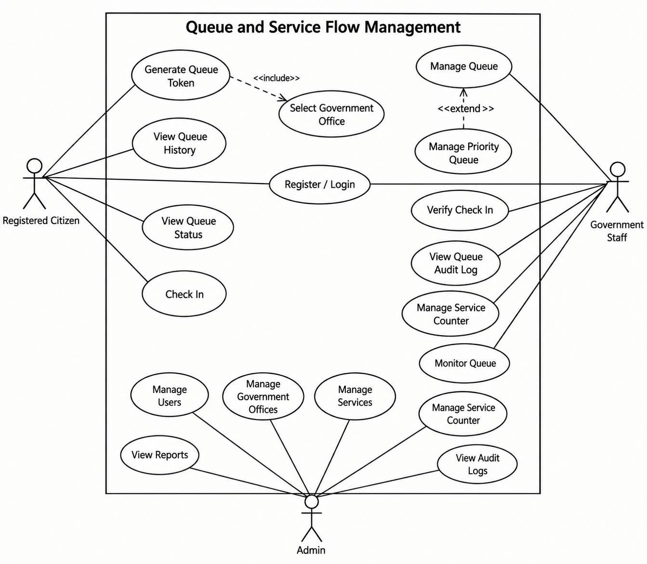
Figure 2.1: Use Case Diagram
ii. Non-Functional Requirements
Table 2.2: Non-Functional Requirements
Area | Requirement
Performance | The system should respond promptly to common citizens, staff, and administrative actions and recalculate queue estimates when significant live events occur.
Availability | The application should remain accessible during intended operating periods and recover from routine service disruptions.
Security | Authentication, authorization, protected configuration, secure handling of credentials, and audit logging should be applied to sensitive operations.
Usability | Citizen workflows should be understood on mobile devices and minimize unnecessary steps.
Maintainability | The frontend, backend, database, and AI components should follow an organized modular structure so that individual features can be modified without unnecessarily affecting unrelated features.
Scalability | The architecture should permit additional offices, services, counters, and stages to be configured without redesigning the complete platform.
Reliability | Queue state changes should remain consistent and auditable, especially around calls, skips, recalls, stage transitions, and completion.
Accessibility | Citizen-facing interfaces should use readable typography, clear status communication, and appropriate interaction patterns.
Bilingual Support | English and Nepali should be available for citizen-facing text, with official service content entered intentionally rather than relying on automatic translation.

2.1.2 Feasibility Study
i. Technical Feasibility
The proposed system uses established web and software-development technologies: React and for the PWA frontend, Node.js/Express for the API, PostgreSQL with Prisma for persistence, Python with pandas and scikit-learn for the AI service, and Socket.IO for real-time communication. These technologies are compatible with the planned feature-by-feature development approach and support separation of citizen, staff, administrator, queue, and AI responsibilities.

ii. Operational Feasibility
The system is operationally feasible as a prototype because it models distinct responsibilities for citizens, staff, and administrators. Citizens use the application to understand and monitor service flow, while staff operate queues and counters and administrators manage configuration and reporting. The design explicitly avoids adding a separate check-in kiosk and instead performs token verification at the actual service counter.
iii. Economic Feasibility
The project is designed as an academic prototype and uses commonly available development technologies and open-source frameworks. The finalized core scope does not require mandatory paid SMS integration, payment processing, or national-scale infrastructure. Any production deployment would require a separate budget assessment for hosting, operational support, security, notifications, and government integration.
iv. Schedule Feasibility
Schedule feasibility is supported by the Incremental Waterfall plan. The project is being implemented in successive increments.
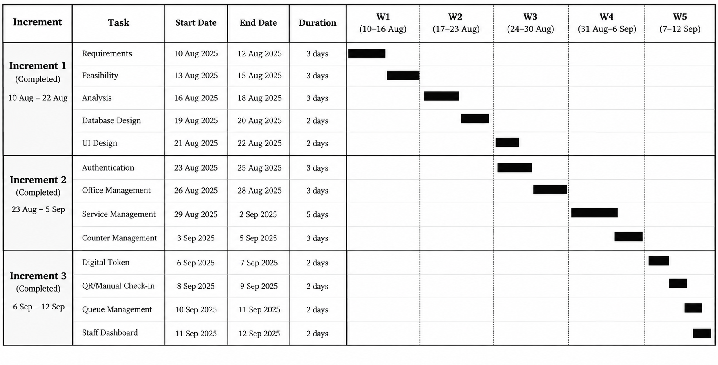
Figure 2.2: Gantt Chart

2.1.3 System Modelling
The project follows the structured modelling approach selected for the report. Data modelling is represented using a conceptual Entity Relationship Diagram (ERD), while process modelling is represented using Context, Level 1, and Level 2 Data Flow Diagrams (DFDs). The models are limited to the current implemented scope for the mid-defense.
- Data Modelling using ER Diagram
The current conceptual data model contains eight implemented entities: Government Office, User, Service Stage, Required Document, Token, Counter, and Notification. The relationships represent office-service ownership, office-staff association, service stages, required documents, token generation and stage assignment, counter service, and user notifications.
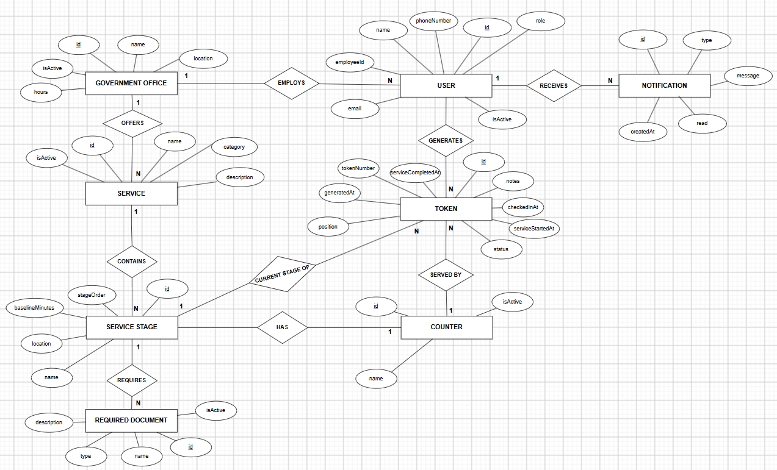
Figure 2.3: Conceptual ER Diagram
- Process Modelling using DFD
The process model represents the implemented service flow through two levels. The Context Diagram treats the Queue and Service Flow Management System as a single process and shows interaction with Citizen, Staff, and Administrator. The Level 1 DFD decomposes the system into account and access management, service information and guidance, token and queue management, counter and service processing, and notification management.
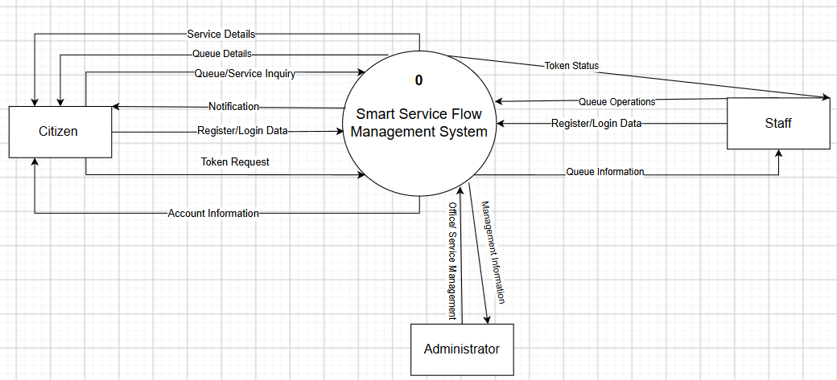
Figure 2.4: Context Diagram
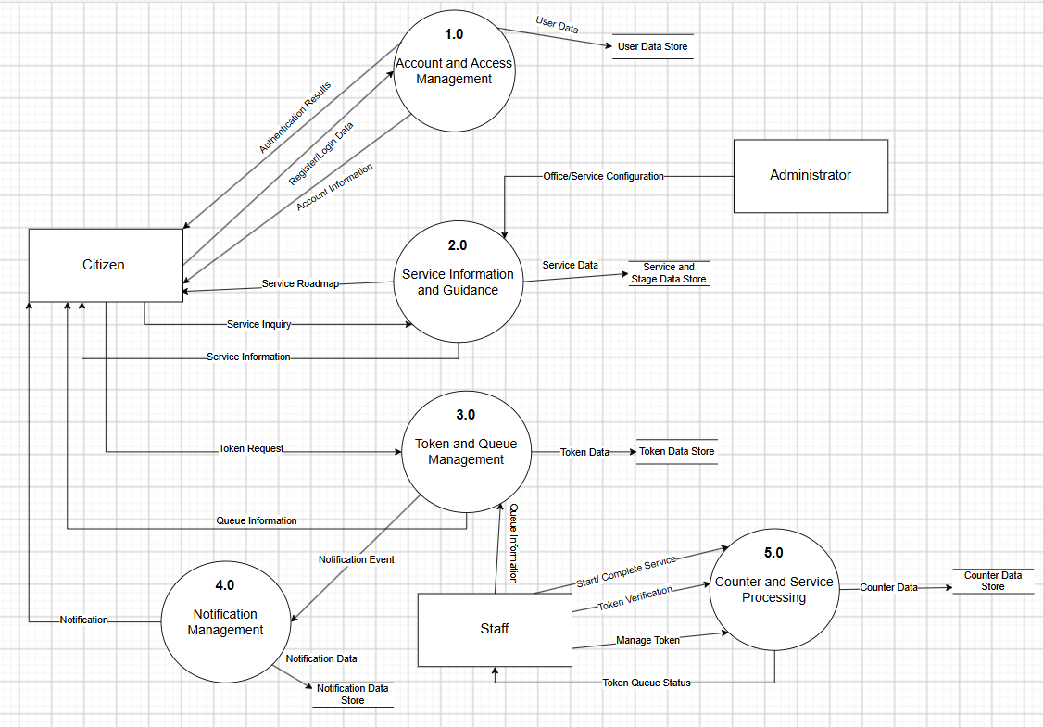
Figure 2.5: Level 1 DFD

2.2 Design

2.2.1 Interface and Dialogue Design
The interface is designed as a practical government service application rather than a generic AI or SaaS dashboard.
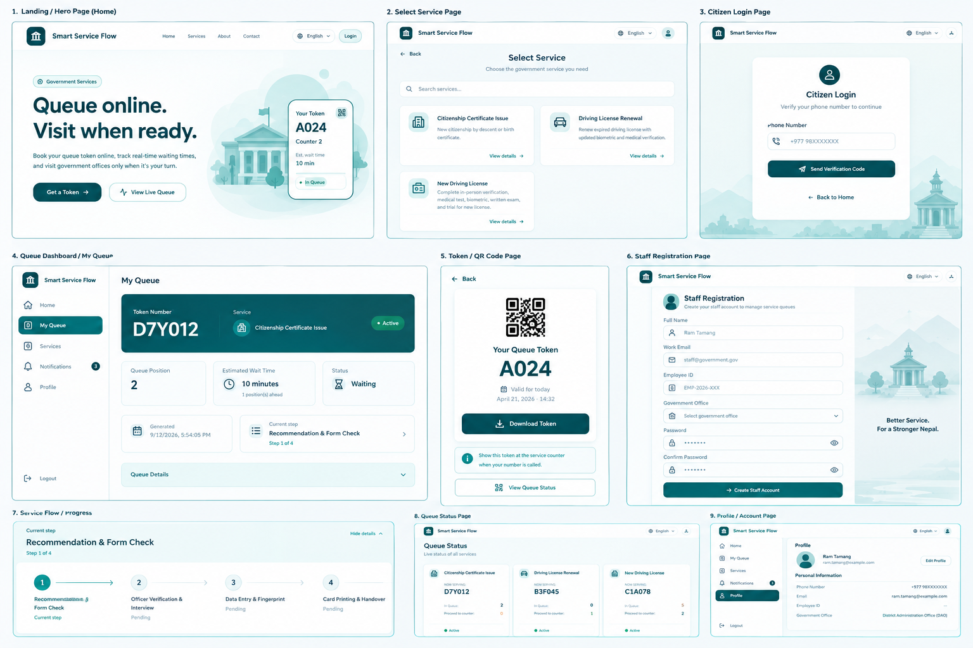
Figure 2.6: High fidelity design of the system

2.2.2 Database Design
The database design transforms the conceptual ER model into relational tables and then evaluates the relations against normalization principles. The current implementation uses PostgreSQL with Prisma ORM.
The following relations represent the current implemented database. Prisma data types are shown exactly as defined in the current schema, while PK and FK labels identify primary and foreign keys.
GOVERNMENT_OFFICE(id PK, nameEn String, nameNe String, location String, hours String, isActive Boolean, createdAt DateTime, updatedAt DateTime)
USER(id PK, phoneNumber String?, email String?, password String?, name String?, employeeId String?, role Role, preferredLanguage Language, isActive Boolean, lastLoginAt DateTime?, passwordChangedAt DateTime?, officeId String? FK, createdAt DateTime, updatedAt DateTime)
SERVICE(id PK, officeId String FK, nameEn String, nameNe String, descriptionEn String?, descriptionNe String?, category String?, isActive Boolean, createdAt DateTime, updatedAt DateTime)
SERVICE_STAGE(id PK, serviceId String FK, stageOrder Int, nameEn String, nameNe String, baselineMinutes Int, location String?, createdAt DateTime, updatedAt DateTime)
REQUIRED_DOCUMENT(id PK, stageId String FK, nameEn String, nameNe String, description String?, type String?, isActive Boolean, createdAt DateTime)
TOKEN(id PK, tokenNumber String UQ, userId String FK, serviceId String FK, currentStageId String FK, position Int, status TokenStatus, generatedAt DateTime, stageEnteredAt DateTime, turnApproachingNotifiedAt DateTime?, calledAt DateTime?, checkedInAt DateTime?, serviceStartedAt DateTime?, serviceCompletedAt DateTime?, completedAt DateTime?, cancelledAt DateTime?, notes String?, qrPayload String?)
COUNTER(id PK, stageId String FK, name String, isActive Boolean, currentTokenId String? UQ, createdAt DateTime, updatedAt DateTime)
NOTIFICATION(id PK, userId String FK, type String, titleEn String, titleNe String, messageEn String, messageNe String, read Boolean, createdAt DateTime)
The current relational design follows First Normal Form (1NF) because each relation has a primary key and ordinary attributes represent atomic values. Repeating groups are separated into dedicated relations such as SERVICE_STAGE, REQUIRED_DOCUMENT, TOKEN, and NOTIFICATION.
The relations satisfy Second Normal Form (2NF) because the main relations use single-attribute primary keys, so non-key attributes cannot depend on only part of a composite primary key. The UNIQUE(serviceId, stageOrder) constraint in SERVICE_STAGE is an additional business constraint rather than the primary key.
The relations are designed toward Third Normal Form (3NF) by keeping attributes with the entity they describe and avoiding repeated storage of parent-entity details. Office details are stored in GOVERNMENT_OFFICE rather than repeated in service-stage records, while stage-specific document information is stored in REQUIRED_DOCUMENT.

2.3 Implementation

2.3.1 Tools and Technologies Used
Table 2.4: Technology Stack
Layer | Technologies
Frontend | React, Vite, Tailwind CSS,
Backend | Node.js, Express
Database | PostgreSQL, Prisma ORM
AI | Python
Real-time | Socket.IO
Version Control | Git, GitHub
Development | Visual Studio Code
Design and Analysis | Draw.io, Figma

2.3.2 Implementation Details of Modules
Authentication and Account Management: The current module handles user registration, login, role information, and language preference.
Service Information: The current module provides government office and service information together with service-stage and required-document data.
Token Generation: The current module generates a digital token, associates it with the selected user and service, and reserves a queue position.
Counter and Token Processing: The current module supports token processing at service counters and maintains token stage and status information.
Notification Management: The current module creates and presents notifications associated with implemented service and token events.
The planned architecture separates predictive estimation from deterministic queue control: a future AI service may predict expected service duration, while the backend queue engine remains responsible for queue state and business rules.

2.3.3 Testing
Testing for the mid-defense focuses on the modules implemented so far. The test cases below identify expected behavior. Actual execution results are not fabricated in this report; they should be recorded from the verified current build before final submission.

Table 2.5: Sample Unit Test Cases
Objective | Expected Result | Actual Result | Conclusion
Register a user | Valid registration data creates a user account. | The user was successfully registered when valid registration details were provided. | Passed
Login with valid credentials | Authenticated user reaches the appropriate interface. | The user successfully logged in and was redirected to the appropriate authenticated interface. | Passed
Browse a service | Service information is displayed correctly. | The selected service information was displayed correctly, including relevant service details. | Passed
Generate a token | A valid token is created with its reserved queue position. | A unique token was successfully generated with the user's reserved queue position. | Passed
Process a token at a counter | The supported token status/stage is updated correctly. | The token was successfully processed, and its status/service stage was updated correctly. | Passed
Receive a notification | The notification is stored and shown to the intended user. |  | Passed
  The notification was successfully stored and displayed to the intended user.
Login with invalid credentials | Users can’t login and is shown invalid login message. | Invalid credentials message was shown and user was not able to login | Passed

CHAPTER III:
CONCLUSION AND RECOMMENDATION

3.1 Summary
The Queue and Service Flow Management System for Government Offices in Nepal has progressed to a mid-defense implementation that establishes the core service-flow foundation. The current system models government offices, users, services, service stages, required documents, digital tokens, counters, and notifications. These modules establish the main data and process structure needed to guide citizens through government service interactions and to support staff-side token and counter processing.
At the current stage, the project demonstrates the transition from a conceptual service-flow problem to an implemented web-based system with a structured database and modular frontend and backend architecture. More advanced queue optimization, real-time communication, dynamic waiting-time estimation, AI prediction, analytics, and additional administrative features remain planned subsequent increments rather than completed mid-defense functionality.

3.2 Conclusion
The current implementation provides the core foundation required for a multi-stage government service-flow platform. The conceptual ER model and relational database design provide a consistent representation of offices, users, services, stages, documents, tokens, counters, and notifications. The system is therefore positioned for later increments that can extend queue behavior and predictive support without changing the core service-flow concept.
The main limitation at this stage is that the project has not yet completed the full planned operational and AI functionality. Consequently, this mid-defense report does not claim production-level queue improvements or machine-learning performance. Such claims should be supported by complete implementation, actual test results, and appropriately representative data in the final report.

3.3 Recommendation
- Implement service-duration history and dynamic waiting-time estimation using real or appropriately anonymized operational data.
- Develop and evaluate the planned AI service-duration prediction component using representative data.
- Add SMS gateway integration for real OTP to the user’s phone.
- Expand administrative, reporting, audit, accessibility, and production-security capabilities before any real-world deployment.
- Evaluate the system across multiple offices and service categories before considering wider adoption.

REFERENCES
Bidari, A., Jafarnejad, S., & Faradonbeh, N. A. (2021). Effect of queue management system on patient satisfaction in emergency department: A randomized controlled trial. Archives of Academic Emergency Medicine, 9(1), e59. https://doi.org/10.22037/aaem.v9i1.1335
Hui, M. K., & Tse, D. K. (1996). What to tell consumers in waits of different lengths: An integrative model of service evaluation. Journal of Marketing, 60(2), 81–90. https://doi.org/10.1177/002224299606000206
Larson, R. C. (1987). Perspectives on queues: Social justice and the psychology of queuing. Operations Research, 35(6), 895–905. https://doi.org/10.1287/opre.35.6.895
Pruyn, A. T. H., & Smidts, A. (1998). Effects of waiting on satisfaction with the service: Beyond objective time measures. International Journal of Research in Marketing, 15(4), 321–334. https://doi.org/10.1016/S0167-8116(98)00008-1
Taylor, S. (1994). Waiting for service: The relationship between delays and evaluations of service. Journal of Marketing, 58(2), 56–69. https://doi.org/10.1177/002224299405800205
Yu, Q., Zhang, Y., & Zhou, Y.-P. (2022). Delay information in virtual queues: A large-scale field experiment on a major ride-sharing platform. Management Science, 68(8), 5745–5757. https://doi.org/10.1287/mnsc.2022.4448

APPENDIX
Appendix A: Output

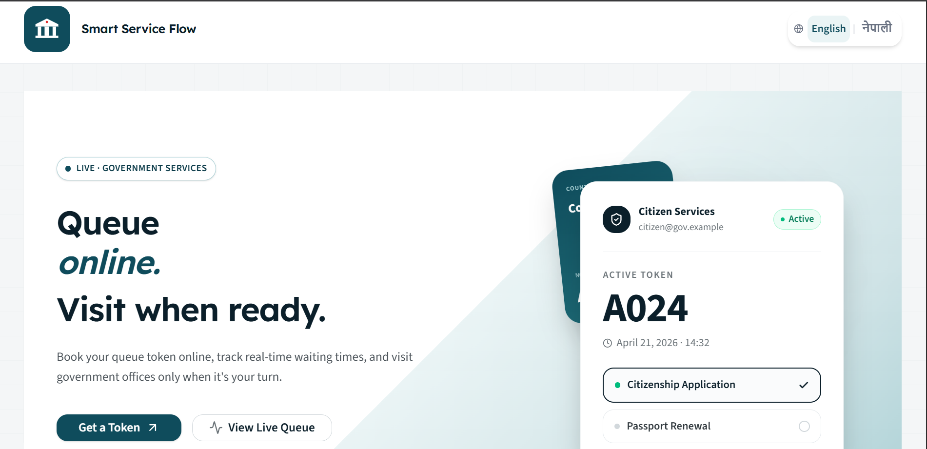
Figure A.1: Landing Page

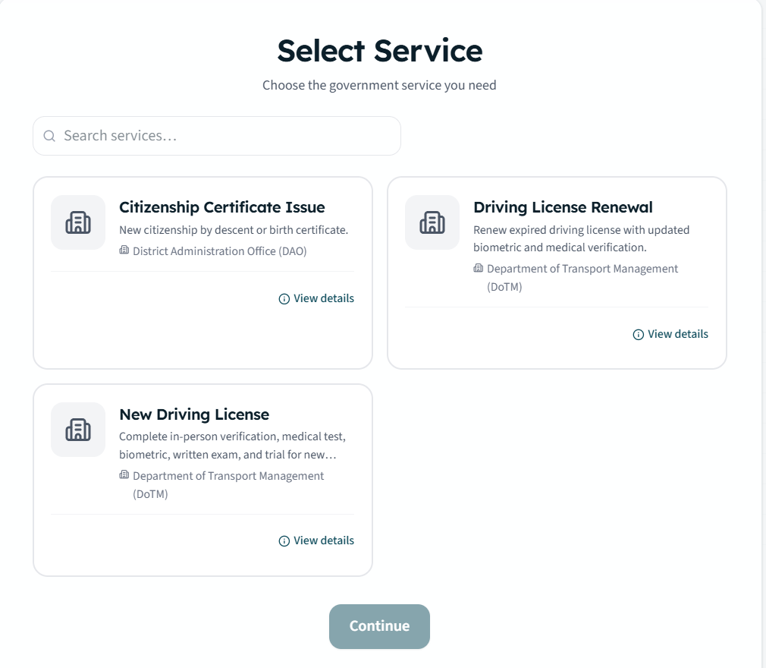
Figure A.2: Service Selection Page

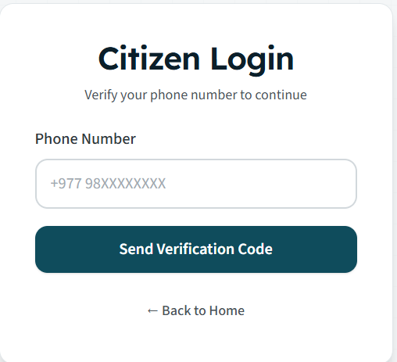
Figure A.3: Citizen Login

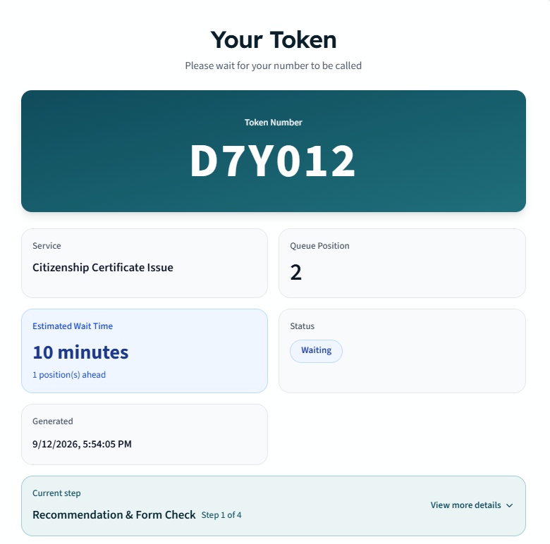
Figure A.4: Display token information

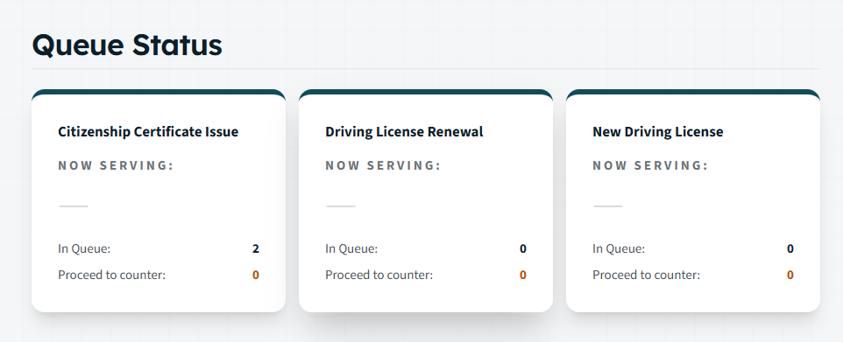
Figure A.5: Monitor current queue

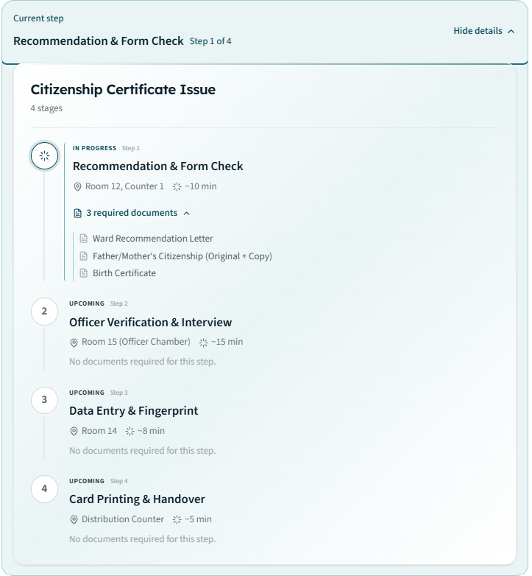
Figure A.6: Service Stages with required documents

